E-COMMERCE ORDER MANAGEMENT DATABASE SYSTEM

WEEK 2: PRODUCT AND CATEGORY MANAGEMENT SYSTEM

CRUD OPERATION REPORT
CRUD operations are performed on the Product table to manage product records. CRUD stands for Create, Read, Update and Delete.

1. CREATE Operation
The CREATE operation is used to add a new product to the Product table.
A new product named Wireless Mouse is added under the Mobile Accessories category with a price of ₹799.00 and stock quantity of 30.

SQL Query
INSERT INTO Product
(Product_Name, Category_ID, Price, Stock_Quantity)
VALUES
('Wireless Mouse', 1, 799.00, 30);
Figure 1: CREATE Operation
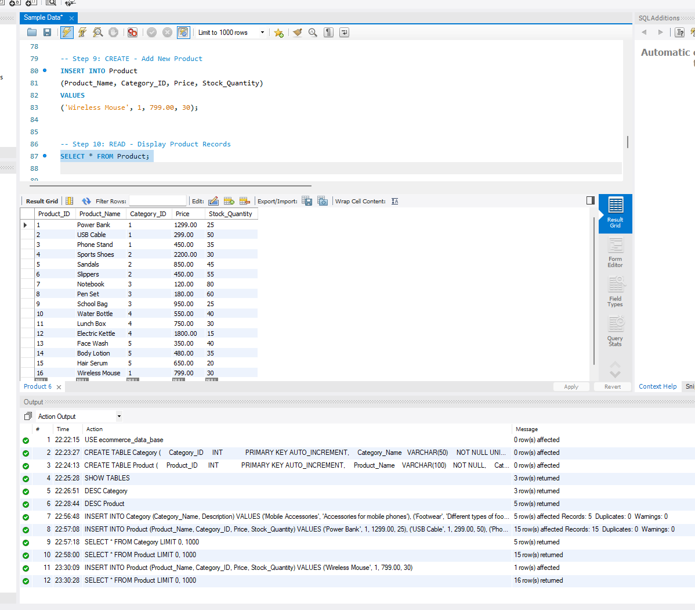

2. READ Operation
The READ operation is used to display the product records stored in the Product table.

SQL Query
SELECT * FROM Product;
This query displays all the product details such as Product ID, Product Name, Category ID, Price and Stock Quantity.
Figure 2: READ Operation

3. UPDATE Operation
The UPDATE operation is used to modify an existing product record.
The price and stock quantity of the Wireless Mouse are updated.
- Old Price: ₹799.00
- New Price: ₹899.00
- Old Stock: 30
- New Stock: 35

SQL Query
UPDATE Product
SET Price = 899.00,
Stock_Quantity = 35
WHERE Product_ID = 16;
To display the updated record:
SELECT * FROM Product
WHERE Product_ID = 16;
Figure 3: UPDATE Operation
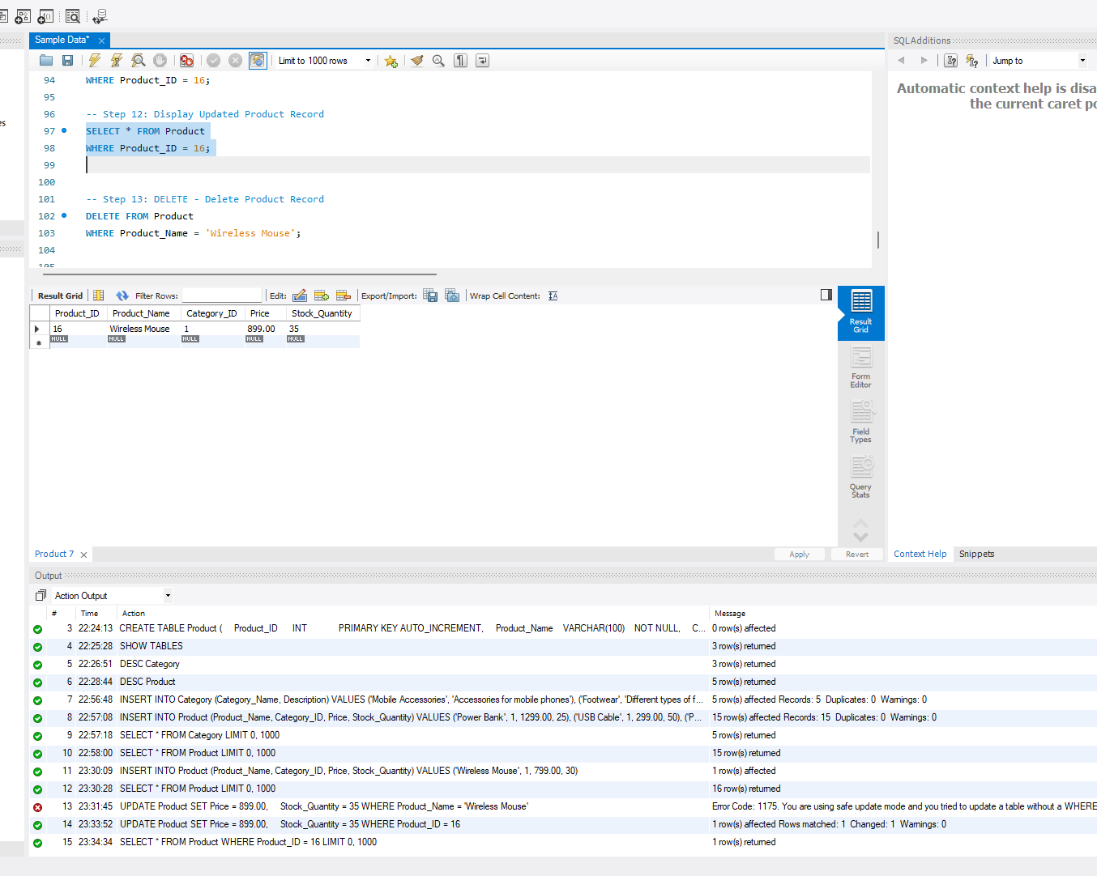

4. DELETE Operation
The DELETE operation is used to remove an unwanted product record from the Product table.
The Wireless Mouse record is deleted using its Product ID.

SQL Query
DELETE FROM Product
WHERE Product_ID = 16;
To verify the final records:
SELECT * FROM Product;
Figure 4: DELETE Operation
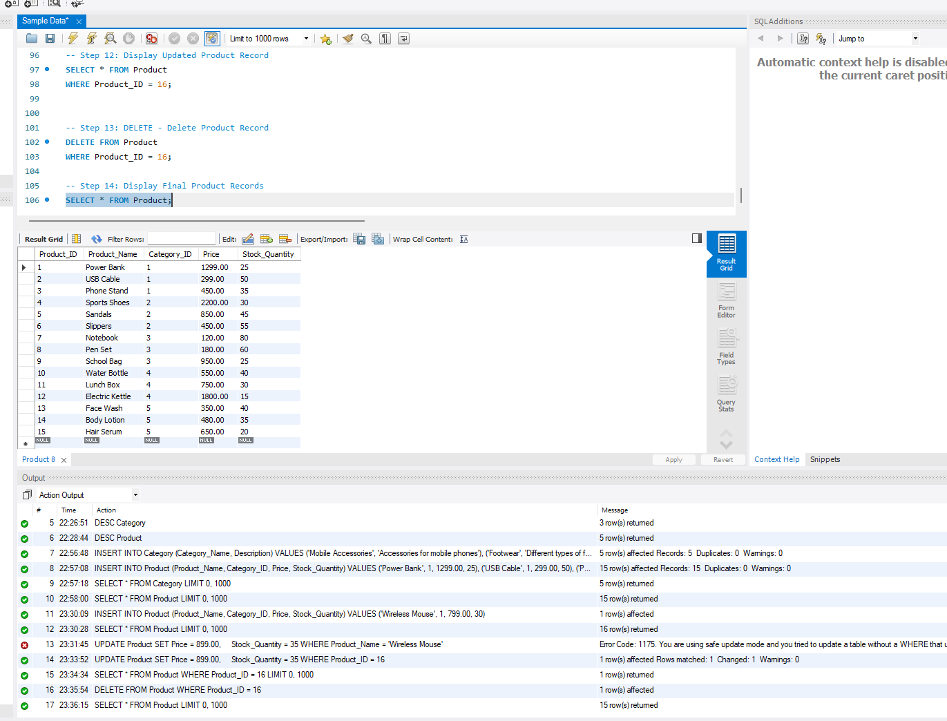

5. CRUD Operation Summary
Operation | Purpose | Product Used
CREATE | Add a new product | Wireless Mouse
READ | Display product records | Product table
UPDATE | Modify product details | Wireless Mouse
DELETE | Remove a product | Wireless Mouse

6. Conclusion
CRUD operations were successfully performed on the Product table. A new product was added, the records were displayed, product details were updated, and the product was finally deleted. These operations help in managing product records effectively.

